Summer
# Source: AI Source: Provided by: [Data Path: Persons Table -> ID Column: 1, Name_En Column: Motasem Essam] -> From: [ChatGPT] on [7/17/2026]
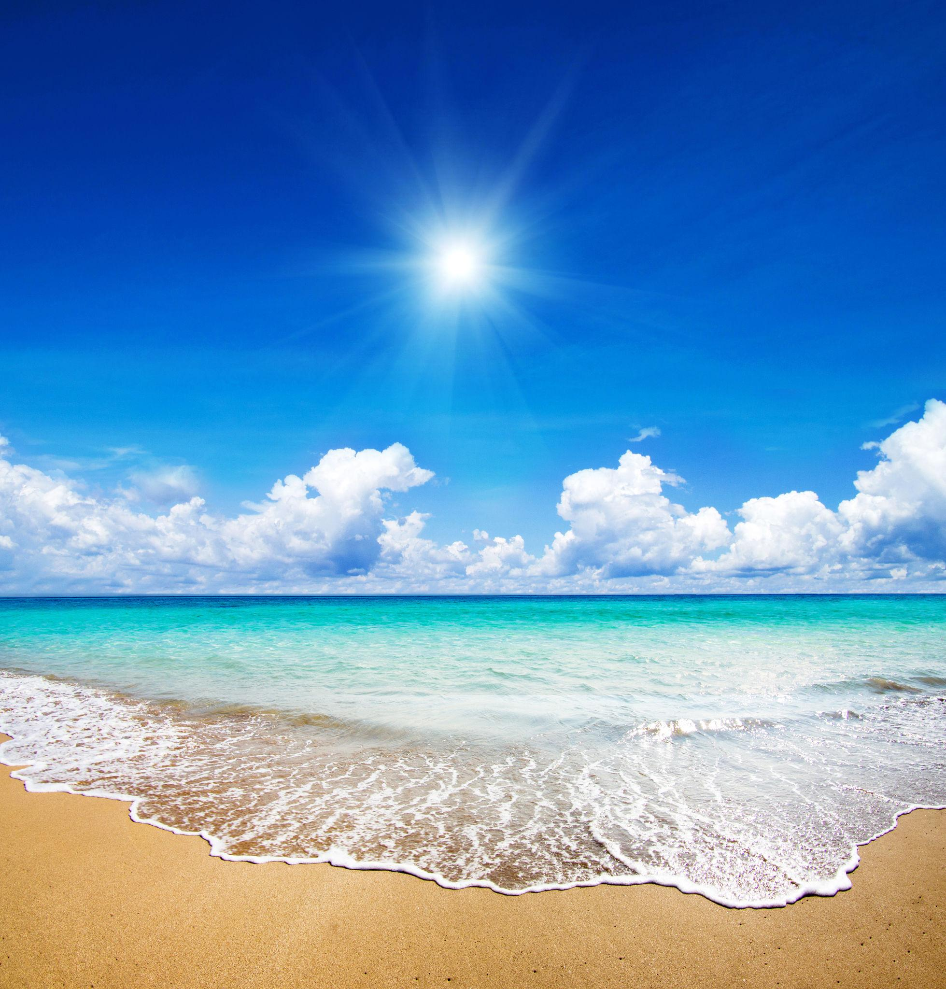
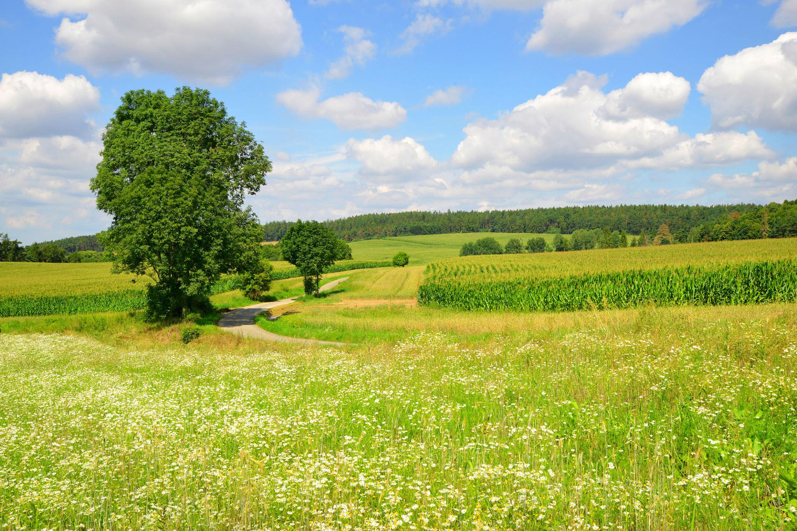

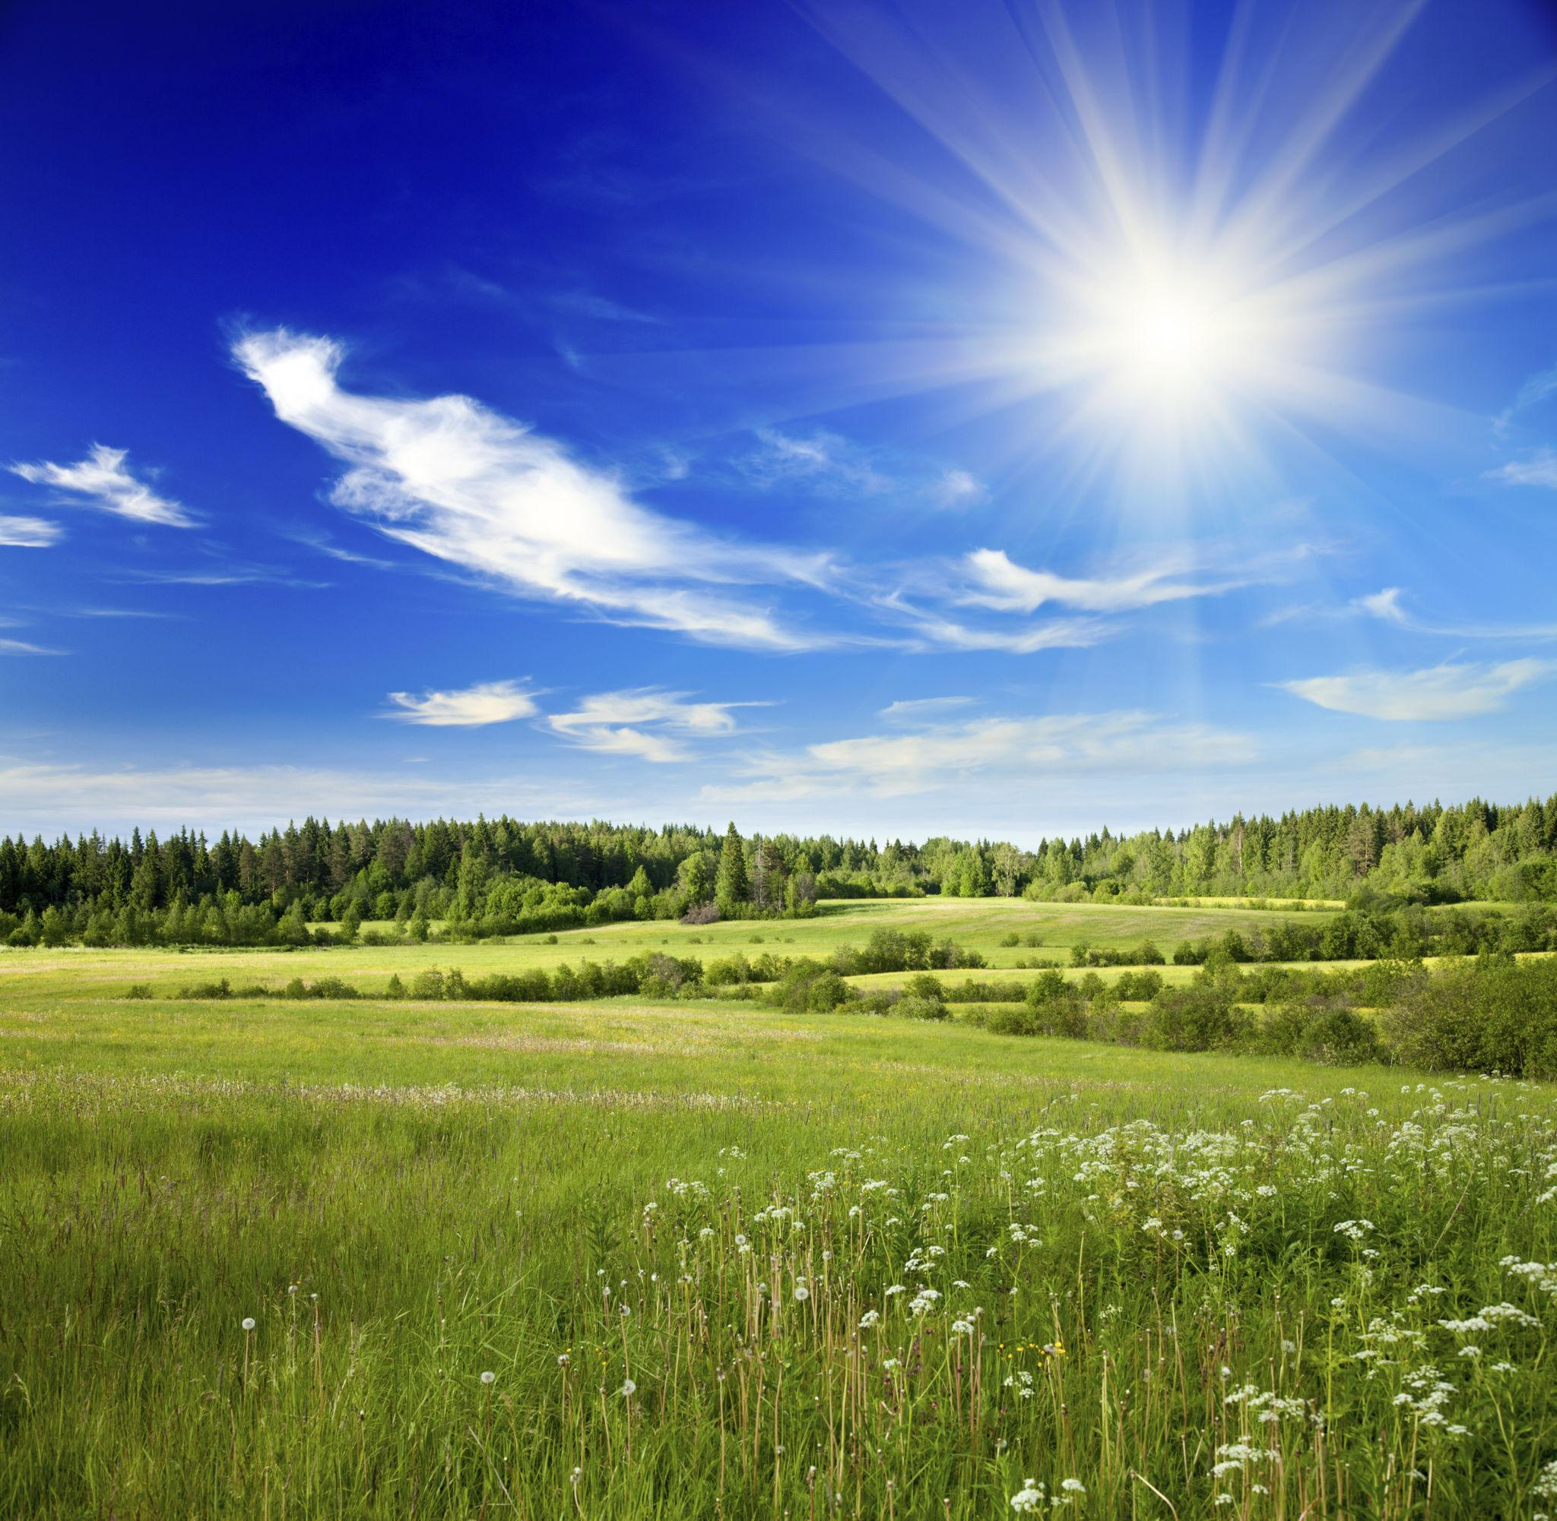
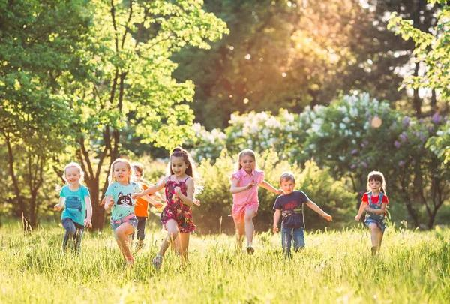
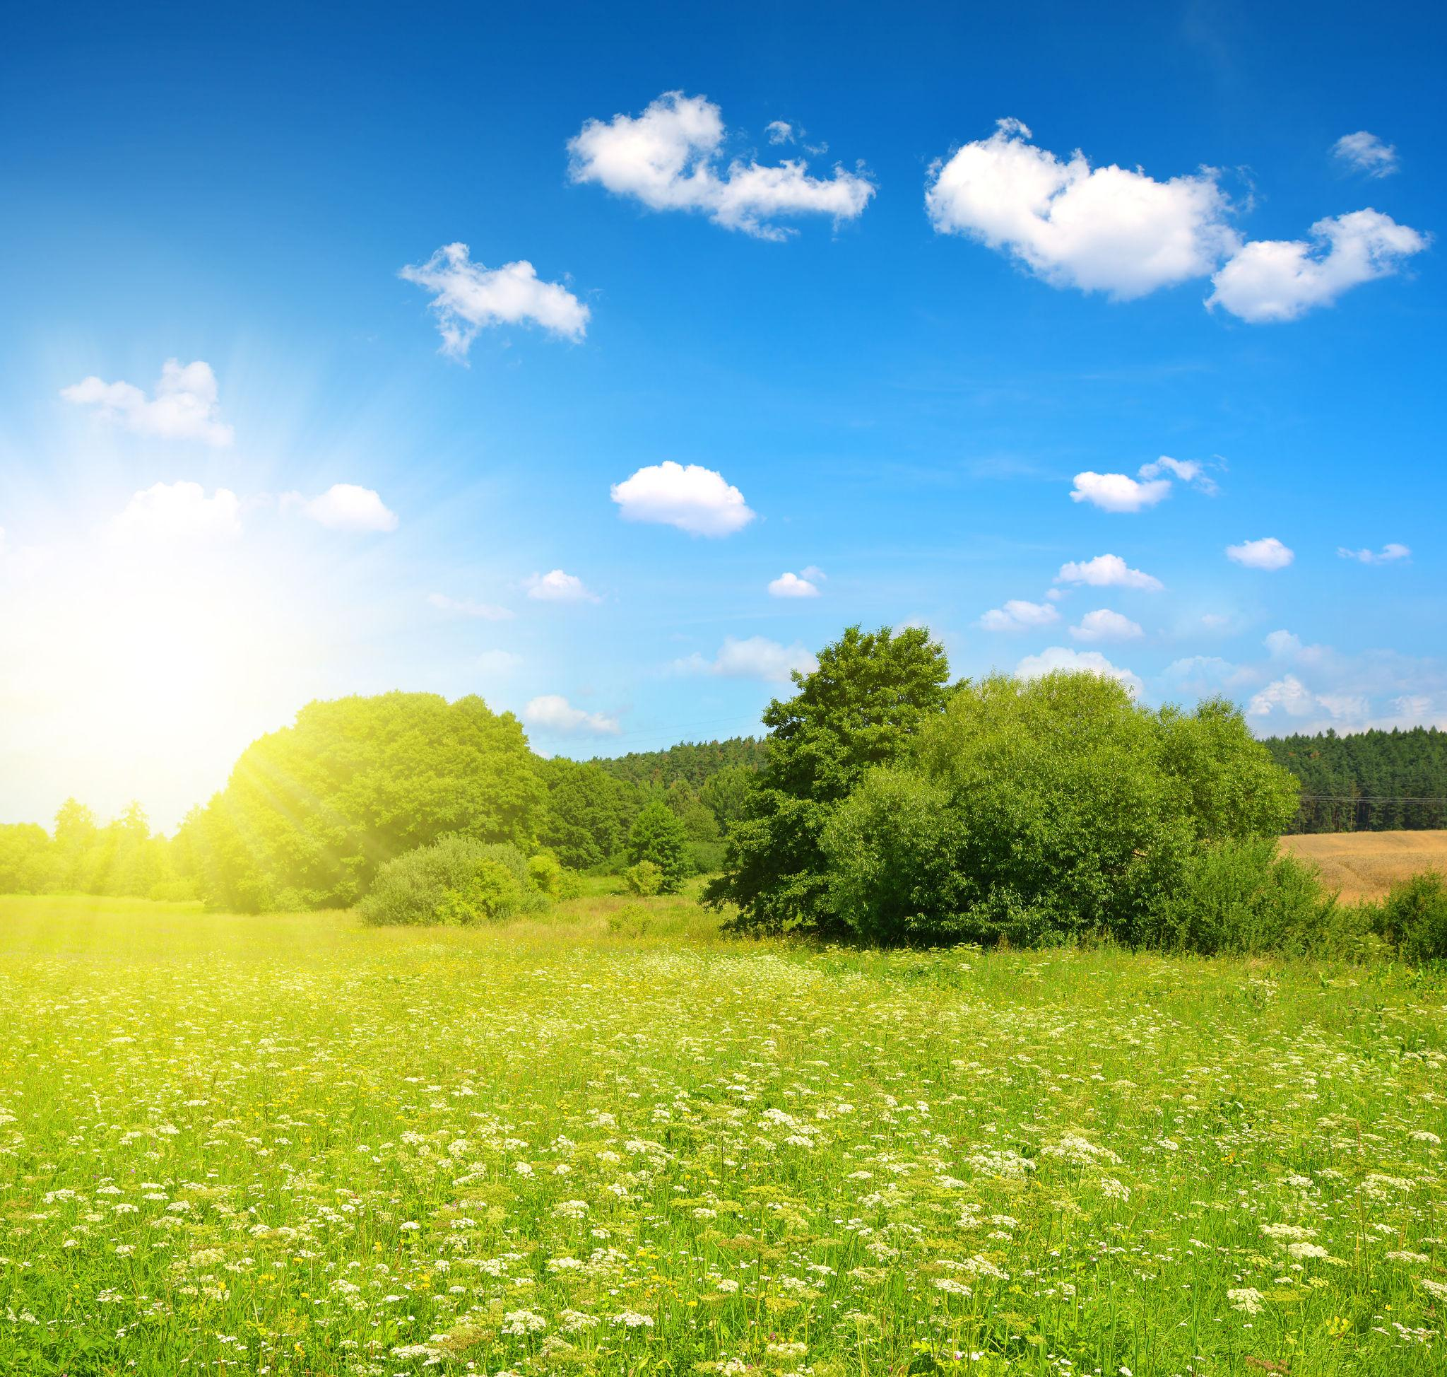
Summer is the warmest season of the year, occurring between spring and autumn (fall). It is characterized by high temperatures, long daylight hours, abundant sunshine, and active plant and animal life.
Summer occurs because a hemisphere is tilted toward the Sun, receiving the most direct sunlight and the longest days of the year.
The relationship between Earth's tilt and the increased sunlight that produces summer is shown below.

Definition
# Source: AI Source: Provided by: [Data Path: Persons Table -> ID Column: 1, Name_En Column: Motasem Essam] -> From: [ChatGPT] on [7/17/2026]
Summer is the season between spring and autumn, characterized by the highest temperatures of the year, the longest daylight hours, and the greatest amount of direct sunlight.

Position in the Year
# Source: AI Source: Provided by: [Data Path: Persons Table -> ID Column: 1, Name_En Column: Motasem Essam] -> From: [ChatGPT] on [7/17/2026]
Summer occurs:
- After Spring
- Before Autumn (Fall)

Typical Months
# Source: AI Source: Provided by: [Data Path: Persons Table -> ID Column: 1, Name_En Column: Motasem Essam] -> From: [ChatGPT] on [7/17/2026]
Northern Hemisphere
- June
- July
- August
Southern Hemisphere
- December
- January
- February

Beginning of Summer
# Source: AI Source: Provided by: [Data Path: Persons Table -> ID Column: 1, Name_En Column: Motasem Essam] -> From: [ChatGPT] on [7/17/2026]
Astronomical Summer
Summer begins at the:
- Summer Solstice
Around:
- June 20–21 (Northern Hemisphere)
- December 21–22 (Southern Hemisphere)
The summer solstice is the day with the longest daylight of the year in that hemisphere.

Weather Characteristics
# Source: AI Source: Provided by: [Data Path: Persons Table -> ID Column: 1, Name_En Column: Motasem Essam] -> From: [ChatGPT] on [7/17/2026]
Summer weather is generally:
- Hot or warm
- Sunny
- Bright
- Dry in some regions
- Humid or rainy in others
Typical conditions include:
- High temperatures
- Strong sunlight
- Warm evenings
- Occasional thunderstorms in many climates

Temperature
# Source: AI Source: Provided by: [Data Path: Persons Table -> ID Column: 1, Name_En Column: Motasem Essam] -> From: [ChatGPT] on [7/17/2026]
Compared with other seasons:
- Summer has the highest average temperatures.
- The Sun reaches a higher position in the sky.
- The ground receives more solar energy.

Daylight
# Source: AI Source: Provided by: [Data Path: Persons Table -> ID Column: 1, Name_En Column: Motasem Essam] -> From: [ChatGPT] on [7/17/2026]
During summer:
- Days are the longest of the year.
- Nights are the shortest.
- The Sun rises earlier and sets later.

Changes in Nature
# Source: AI Source: Provided by: [Data Path: Persons Table -> ID Column: 1, Name_En Column: Motasem Essam] -> From: [ChatGPT] on [7/17/2026]
Summer is a period of vigorous growth and activity.
Plants
- Crops grow rapidly.
- Trees have full foliage.
- Many fruits and vegetables ripen.
- Flowers continue blooming.

Animals
# Source: AI Source: Provided by: [Data Path: Persons Table -> ID Column: 1, Name_En Column: Motasem Essam] -> From: [ChatGPT] on [7/17/2026]
- Many birds raise their young.
- Insects are highly active.
- Mammals forage extensively.
- Reptiles and amphibians are more active in warm weather.

Agriculture
# Source: AI Source: Provided by: [Data Path: Persons Table -> ID Column: 1, Name_En Column: Motasem Essam] -> From: [ChatGPT] on [7/17/2026]
Summer is an important agricultural season.
Activities include:
- Irrigation
- Crop maintenance
- Harvesting certain fruits and vegetables
- Pest management

Human Activities
# Source: AI Source: Provided by: [Data Path: Persons Table -> ID Column: 1, Name_En Column: Motasem Essam] -> From: [ChatGPT] on [7/17/2026]
People often:
- Go on vacations.
- Swim and visit beaches.
- Camp and hike.
- Play outdoor sports.
- Hold festivals and outdoor events.

Major Summer Celebrations
# Source: AI Source: Provided by: [Data Path: Persons Table -> ID Column: 1, Name_En Column: Motasem Essam] -> From: [ChatGPT] on [7/17/2026]
Examples include:
- Midsummer festivals (various countries)
- Independence Day celebrations (in some nations)
- Summer cultural fairs
- Local harvest festivals in some regions

Importance of Summer
# Source: AI Source: Provided by: [Data Path: Persons Table -> ID Column: 1, Name_En Column: Motasem Essam] -> From: [ChatGPT] on [7/17/2026]
Summer is important because it:
- Provides ideal conditions for plant growth.
- Supports food production.
- Encourages outdoor recreation.
- Increases solar energy availability.
- Contributes to ecosystem productivity.

Advantages
# Source: AI Source: Provided by: [Data Path: Persons Table -> ID Column: 1, Name_En Column: Motasem Essam] -> From: [ChatGPT] on [7/17/2026]
Summer offers:
- Long daylight hours
- Warm weather
- Active wildlife
- Outdoor recreation opportunities
- Strong plant growth

Challenges
# Source: AI Source: Provided by: [Data Path: Persons Table -> ID Column: 1, Name_En Column: Motasem Essam] -> From: [ChatGPT] on [7/17/2026]
Summer may also bring:
- Heat waves
- Droughts
- Wildfires in dry regions
- Increased risk of dehydration
- Higher energy use for cooling

Comparison with Other Seasons
# Source: AI Source: Provided by: [Data Path: Persons Table -> ID Column: 1, Name_En Column: Motasem Essam] -> From: [ChatGPT] on [7/17/2026]
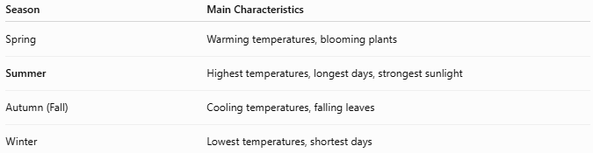
Season | Main Characteristics
Spring | Warming temperatures, blooming plants
Summer | Highest temperatures, longest days, strongest sunlight
Autumn (Fall) | Cooling temperatures, falling leaves
Winter | Lowest temperatures, shortest days

Common Mistakes
# Source: AI Source: Provided by: [Data Path: Persons Table -> ID Column: 1, Name_En Column: Motasem Essam] -> From: [ChatGPT] on [7/17/2026]
- Assuming summer is equally hot everywhere (its intensity varies by latitude, altitude, and climate).
- Believing the Earth is closer to the Sun during summer (the main cause is the Earth's axial tilt, not its distance from the Sun).
- Assuming both hemispheres experience summer at the same time (they experience opposite seasons).

Key Points
# Source: AI Source: Provided by: [Data Path: Persons Table -> ID Column: 1, Name_En Column: Motasem Essam] -> From: [ChatGPT] on [7/17/2026]
- Summer is the season between spring and autumn.
- It begins at the Summer Solstice.
- It has:
  - The highest temperatures
  - The longest daylight hours
  - The most direct sunlight
- Plants grow rapidly and many crops mature.
- It is an important season for agriculture, tourism, and outdoor activities.

Conclusion
# Source: AI Source: Provided by: [Data Path: Persons Table -> ID Column: 1, Name_En Column: Motasem Essam] -> From: [ChatGPT] on [7/17/2026]
Summer is the warmest season of the year, marked by high temperatures, extended daylight, and abundant sunshine. It occurs when a hemisphere is tilted toward the Sun, allowing it to receive the greatest amount of solar energy. These conditions promote rapid plant growth, active wildlife, and numerous human outdoor activities, making summer one of the most productive and energetic seasons of the year.

